Vision Statement for Native Literature and AP at NACA

Vision Statements articulate the long-term objectives of the content area, juxtapose that vision to the current state of teaching and learning at the school, and plan for a five years of action to meet the vision.

All “elements” should be in narrative form. The use of research statistics and graphics to support claims is encouraged.

Element 1 – Vision for Native Literature at NACA
Five years from now, what will a graduating senior look like as a result of a NACA her Native Literature and AP curriculum? What skills does she possess? What knowledge? What dispositions? What understandings guide her actions?

What is Native Literature and why is it important?

While “multicultural literature” is commonly taught in American schools, it is frequently placed at the periphery rather than the center of literacy instruction. Students read works by Native American, African American, and Hispanic authors as occasional accents that punctuate a stream of texts by white male authors, which are viewed as central and more significant.

In teaching Native Literature courses during students’ Grades 6-10 experience at NACA, the goal is to reenvision this dominant framework. Native Literature comprises works that are written by Native American and global indigenous authors, both in the past and present. Texts within this category display great diversity: diversity of literary style, of authorial perspective and cultural background. Yet, Native Literature also presents deep connectedness, as native authors explore themes that arise from shared perspectives as well as a common historical experience and struggle for sovereignty. In addition, Native Literature is a field in constant flux, as participants debate the exact definition of this category and seek to revive and sustain traditional literacies, including storytelling and native language texts. For our students, studying Native Literature is important because it allows them to develop literacies that connect to their identities and the traditions of their communities, literacies that are ultimately empowering to them as individuals, community members, and young Native American leaders.

Vision:
We envision students critically reading and interpreting texts so that, in the long-run, on their own, they will be able to draw inspiration and power from written words that resonate with them, analyze and critique the underlying assumptions and perspectives presented in a variety of texts, and read,write, and speak in ways that empower them as indigenous individuals, community members, and leaders.

Knowledge | Students will know the vocabulary required for college-level literary interpretation.  Students will know that stories transmit and create culture.  Students will know seminal pieces from Native American, global indigenous, and other literatures.
Skills | Students will be able to read and comprehend a wide range of literature and informational texts.  Students will be able to write skillfully in a variety of genres for different audiences and purposes using the stages of the writing process.  Students will be able to read texts with a critical lens, determine the author’s point of view and identify connections that support or contradict what they are reading.  Students will be able to actively engage in reading and writing tasks within a community, for specific, authentic purposes and also for the pleasure of reading and creating literature.  Students will be able to tackle difficult reading tasks with a variety of tools including annotation, close reading, research, and collaboration.  Students will be able to develop insightful interpretations of texts and support these with well-chosen evidence and analysis that develops the interpretation in a detailed, logical, and elegant way.  Students will be able to use a variety of lenses to interpret texts, including traditional tools of literary analysis (theme, mood, tone, symbolism, etc.) as well as perspectives that consider historical, cultural, and social implications.  Students will be able to participate in high-level class discussions by presenting ideas clearly, providing elaboration when necessary, listening carefully to others, and building on and responding to peers’ ideas.
Understandings | Students will understand that literacy is a tool allowing one to develop a greater sense of self and to participate in communities and that strong literacy skills are necessary for success in all disciplines.  Students will understand that Native American and global indigenous literatures are rich traditions that are worthy of study and offer dynamic opportunities for students’ scholarly and creative contributions..  Students will understand that they should be able to see themselves in literature, but also recognize and appreciate the differences between a variety of cultures, indigenous and global.
Dispositions | Students will acquire the mindset that reading and writing are ceremony, and like ceremony, contain tedious elements that require composure. But also like ceremony, reading and writing connect, teach and heal. The intellectual and spiritual rewards of reading and writing are worthy of the time, effort, and struggle they require.

What senior summative assessment will evaluate student ability, and therefore teacher and school ability, against the objectives of Native Lit. and AP? Describe the assessment here.

Mission: Academically prepared, secure in their identity, healthy

To demonstrate graduation proficiency in Native Literature and AP, students will…
Exceeds proficiency: Approximately ⅔ of NACA Juniors and Seniors will take an Advanced Placement English class (either Literature and Composition and/or Language and Composition). To exceed proficiency in both Native Literature and AP, these students will take the AP Exam and earn a composite score of 3 or higher, and thereby earn college credit for an entry level English or Composition course.
Proficient:
- participation in a Poetry Circus and subsequent community discussion panel
- publication of a literary review (a la NY Times Book Review) - electronic or hard copy
- completion of a writing portfolio that demonstrates growth (or a best work portfolio) - electronic and/or hard copy
- complete an effective, elegantly written essay for the Common App (or other, e.g., scholarship requirement)

Element 2 – The Current State of Native Literature at NACA
What information/data do we currently possess about our current success and challenges in meeting the Native Literature and AP vision?

We currently have information from a variety of sources, including the Discovery Education reports and data from classroom assessments aligned to several key skills in the middle school grades: analytical writing (including thesis statements, evidence, and
analysis of support) and participation in student-led discussions.

The DE Benchmark results portray the current emphasis on literary texts in the curriculum, as indicated by the relatively high proportion of students answering most of that question type correctly. A significantly lower proportion of students correctly answer the language (spelling, grammar, punctuation, and usage) questions correctly, indicating a need for greater emphasis in the curriculum on precision in writing.

The lower proportion of students correctly answering most questions about informational texts suggests a need for literacy to be an emphasis in all content area classrooms. Reading and writing are skills necessarily taught and reinforced in each content area with discipline-specific text types. Students must become familiar with how to read and write scientific, historical, and mathematical texts. The Native/AP Literature team sees an opportunity to develop common literacy practices that can be taught to students and revisited in all classrooms.

The middle school classroom data indicates a number of strengths in Native Literature that can be expanded from the current middle school to high school Pre-AP Native Literature and AP Literature classes. The middle school has already created structures and strategies to ensure alignment from one grade to the next in terms of annotations, mini-essays, and student discussions. Additional work, however, needs to be done in examining both the standards and anchor papers across grade levels to ensure reliability of teacher-reported performance data, within the literature classes and other classes, including Indigenous History, at NACA.

Overall, the scores point to a need to improve the rigor of literacy instruction in order to prepare all NACA students for college success.
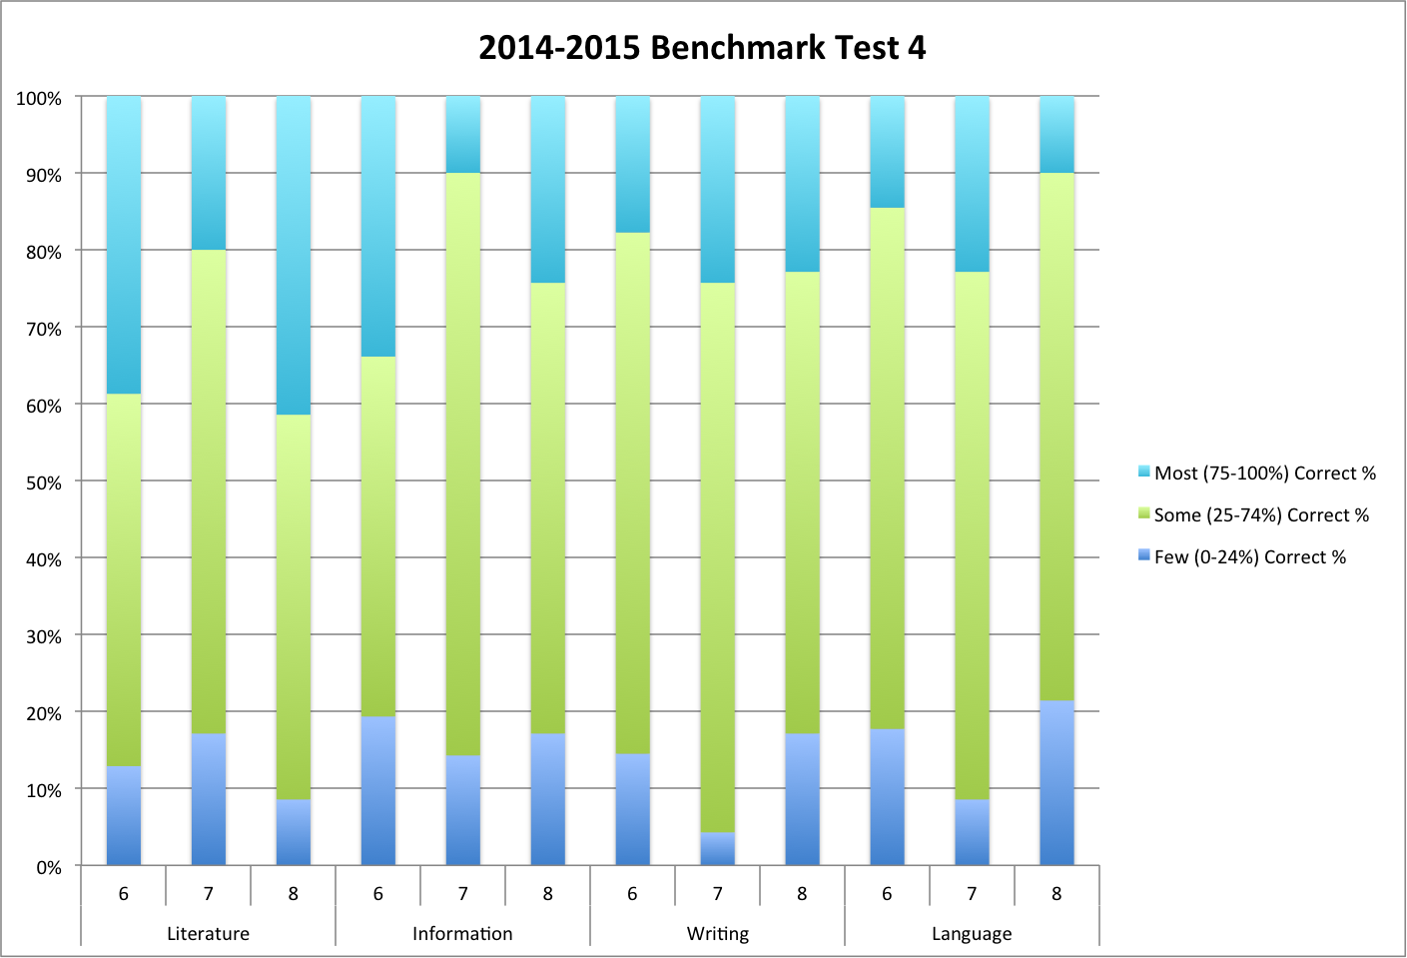
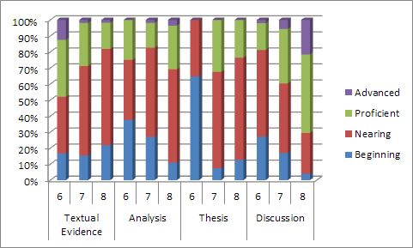

Element 3 – The Five-year Plan
With the goal of achieving the vision, what is possible next year? The year after? Complete the five-year plan, and please use measurable objectives.

SY 2015-2016 In order to prepare students for success in a variety of contexts they will be engaged in the creation of portfolios to document their growth as readers and writers. Students will have multiple opportunities to craft narratives and literary analyses in each grade and will reflect on their strengths/weaknesses especially as it correlates to writing. Additionally, students will be introduced to a standards-based grading system which connects their portfolio entries and summative performance tasks. To initiate this process, the Native Literature team will prioritize the following professional development activities:
- Determine criteria for proficient essay-writing at each grade level based on examination of end-of-year writing products and with reference to Appendix C writing exemplars in the Common Core.
- Based on alignment of essay-expectations, develop rubrics to be used by both teachers and students (self-assessment of work).
- Implement standards-based grading system via Canvas software and ensure that both teachers and students develop fluency in their use of this grading system.
At the conclusion of the school year, teachers will identify students who have demonstrated readiness for the rigor of Advanced Native Literature for the upcoming school year . Summer reading will be assigned for these students in order hit the ground running when the 2016-2017 school year commences. By implementing portfolios and standards based grading, we hope that our students are able to meaningfully engage in a learning experience that considers their personal growth and achievement, while fostering a love of literacy.

SY 2016-2017 After observing the data from our short cycle assessments, writing samples and anecdotal notes/observations it appears that writing is an area that needs attention. Writing with precision and clarity, and perseverance in extended writing tasks are specific growth areas for our students. Therefore, the 2016-2017 school year will be devoted to improving our writing instruction and methods. Our team plans to engage in an action research project with a mentor who can help us identify and implement teaching strategies that translate to students producing quality essays, literary analyses and narratives. After spending the school year engaged in this project, the team envisions having at least one tried and true strategy that can be implemented in all Native Literature/AP classes and becomes a core part of the writing instruction within the content area.

SY 2017-2018 While much work has been done in aligning curriculum in the middle grades, 6-8, this year will be spent developing cohesion between the middle and high school classes, especially in the area of Advanced Placement (AP). This will require that all Native Literature teachers in grades 6-10 attend Pre-AP training to become familiar with the program and its standards. To move forward the team will need to analyze CCSS and AP standards, then examine curriculum to identify gaps or redundancy. Additionally, we need to ensure that rigor and high expectations are scaffolded appropriately to ensure students are ready for AP and have the tools to necessary to succeed in this setting.

SY 2018-19 By this year, our team will have implemented standards-based grading and portfolios for three years. This timeframe should be sufficient for us to analyze our process and the student outcomes. We hope to see this practice extended school-wide and are willing to share our trials and successes with NACA staff to demonstrate how these assessment practices provide a true learning and meaningful record of student learning. Ideally, we envision leading the movement to have NACA consider replacing the typicalEnd of Year Demonstrations with portfolio presentations or have Student Led Conferences become portfolio conferences.

SY 2019-20 80% of NACA 11th and 12th graders (our current 6th and 7th graders) will pass the AP exam AND the team will host a NACA Native Literature Symposium where students will highlight their authentic work in this field.

http://www.celt.iastate.edu/teaching-resources/effective-practice/revised-blooms-taxonomy/ http://static.pdesas.org/content/documents/M1-Slide_19_DOK_Wheel_Slide.pdf

