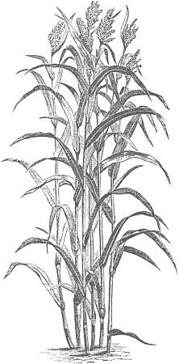
School Day: ___/___/2015 Unit: ____________
EE
Sihasin (Reflection Process) – SOUTH  Essential Question Answers from Students (used as formative assessment and teacher reflection): | Nitsáhákees (Thinking Process) – EAST  Daily Essential Question:
Iiná (Applied Learning) - WEST  Experiential Education Activity of the Day:  Experiential Education Objectives of the Day: | Naha'tá (Planning and Skills) – NORTH  ELA Skill (Wonders) Objectives of the Day:  Math Skills (Engage NY) Objectives of the Day:

